**Peer pressure**

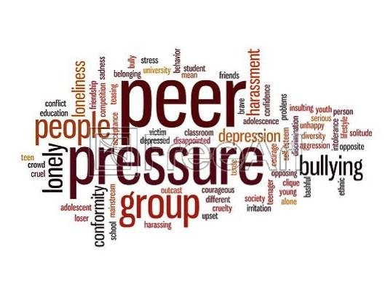

Peer pressure is one of the reasons of most of the crimes, depression and suicide. This is the core problem of today’s generation. The term ‘ peer pressure' means the direct or indirect influence on one person by peers (group of persons of same age). Peer pressure can be of positive or negative ,but most of the time it is negative. This pressure encouraged the person to change their behaviour , attitude, and values. Sometimes people even change their way of living, talking style, dressing to fit in the peer group.

**Peer pressure in adolescence**

This term is most popular refer to the influences felt by adolescents. Adolescents are more susceptible to peer pressure. In this age people spend most of their time with their peers so, they have their impact on them. At this age so many new thoughts take place in the mind of adolescents. They tries to make their place in the society, they want that everyone’s attention, praise and appreciation. And for that they depend on their peers . They tries to imitate their peers to become popular. They don’t think about the consequences of their acts. They all want to be fit in the society and in their peer group and for that they do everything. They forget their real values and attitude. It’s all depends on the choice of peer group , if people get the right peers then this peer pressure will encourage them to become better and help them to achieve success in their life but if this choice is wrong then everything become worst .

**Depression and Peer Pressure**



Peer pressure can also become the reason of depression, but not only depression sometimes even suicide. Peer pressure specifically negative is very harmful and dangerous (especially for adolescents). Because in this age people just do the things without knowing their consequences. They are afraid of being of not to be fit in or ignored by peers and society. They know what is right and what is wrong but still chooses the wrong because of their fear. They lose their real identity , their values . They lose themselves. And when they do not become the one who they are not they get depressed with the thought of become a laughing stock in front of their peers . As being different or not to be fit in is a problem for the society.

**How to Overcome Peer Pressure**

1. **Don’t forget your values**

Everyone has different values which make them unique. You also have some unique value , never forget them in someone’s pressure. Respect what you are never change yourself ,your true identity, to become what you are not. Always think about your values ,why you have them . There is always a reason behind everything so, try to find that reason . You will become what you are and what you deserve to be.

1. **Assert yourself**

Be assertive . Try to become more confident about yourself, about your decisions about your wishes and about your everything. Don’t be hesitate to that ‘I like' , ‘I wish' etc. Give equal important to yourself too.

1. **Try to open with wide range of people**

Interact with as many people as you meet . Don’t be afraid of them. Share your views with the world and let you know their views also . You’ll find out that everyone has different views and everyone’s view matter to the world .

1. **Avoid the criticism**

Do whatever you want to do . Don’t listen what people say . Nothing matters until you follow your heart , so just avoid the criticism of society. People will always find some fault and say something. This is not the thing that matters , what matters is you , your wishes , your values so, always follow your values.

Peer pressure is not bad. It can be good if the peers pressurize for the good things. But most of the time it’s negative and have bad effect on the people especially adolescents . So , what you need to do is try to follow your inner voice and be careful in choosing your peer group as this matters a lot in your life.